Page0



**Internship Report**

**On**

**(Machine Learning With Python)**

**Submitted by Submitted to**

**[Satyam Tiwari] Mallika Srivastava**

**[113] Head, Training Delivery**

**[B K Birla College Kalyan] EISystems Services**

**&**

**Mayur Dev Sewak**

**Head, Internships & Trainings EISystems Services**

Page1

**Student’s Declaration**

I, Satyam Jayaprakash Tiwari ,a student of B.Sc program, Roll No. 113 of the Department of Information Technology , B K Birla College do hereby declare that I have completed the mandatory internship in Eisystems Technologies under the faculty guideship of Mrs. Esmita Gupta, Department of Information Technology

, B K Birla College Kalyan .



1-5-2024

Endorsements



[Mrs. Esmita Gupta, HOD] [Information Technology] [B K Birla College Kalyan]

Page2

# Table of Content

|  |  |  |
| --- | --- | --- |
| **Serial No** | **Title** | **Page No** |
| **1.** | **Executive Summary** | **5** |
| **2.** | **Overview of Organization** | **6** |
| **3.** | **Project Summary** | **7** |
|  | * 1. **Quiz Game Development using Python**   2. **Area Price Prediction using Python and Google Colab**   3. **Insurance Purchase Prediction using Python and Google Colab**   4. **Gender Prediction using Python and Google Colab**   5. **Iris Flower Data Analysis with K-Nearest Neighbors**   6. **Titanic Survival Prediction using Python and Google Colab**   7. **image classification using Python and Google Colab** | **7-10** |
| **4.** | **Data Flow Diagram / Process Flow** | **11** |
| **5.** | **Code / Program with Supported Screenshots** | **12** |
|  | * 1. **Quiz Game Development using Python**   2. **Area Price Prediction using Python and Google Colab**   3. **Insurance Purchase Prediction using Python and Google Colab**   4. **Gender Prediction using Python and Google Colab**   5. **Iris Flower Data Analysis with K-Nearest Neighbors**   6. **Titanic Survival Prediction using Python and Google Colab**  5.7 image classification using Python and Google Colab | **12-20** |
| **6.** | **Input / Output with Datasets & Supported Screenshots** | **21** |
|  | * 1. **Area Price Prediction using Python and Google Colab**   2. **Insurance Purchase Prediction using Python and Google Colab**   3. **Gender Prediction using Python and Google Colab**   4. **Iris Flower Data Analysis with K-Nearest Neighbors**   5. **Titanic Survival Prediction using Python and Google Colab**  6.6 image classification using Python and Google Colab | **21-22** |
| **7.** | **Images / Video Links** | **23** |
| **8.** | **References** | **24** |
| **9.** | **Student *Self Evaluation of the Short-Term Internship*** | **25** |
| **10.** | **Annexure 1 Daily Activity Report** | **26-29** |
| **11.** | **Annexure 2 Weekly Progress Report** | **30-31** |

.

Page3

**List of Figures**

|  |  |  |
| --- | --- | --- |
| **Serial No** | **Image Caption** | **Page No** |
| **1.** | Figure 1 | 11 |
| **2.** | Figure 2 | 12 |
| **3.** | Figure 3 | 14 |
| **4.** | Figure 4 | 15 |
| **5.** | Figure 5 | 16 |
| **6.** | Figure 6 | 18 |
| **7.** | Figure 7 | 19 |
| **8.** | Figure 8 | 20 |
| **9.** | Figure 9 | 21 |
| **10.** | Figure 10 | 21 |
| **11.** | Figure 11 | 22 |
| **12.** | Figure 12 | 22 |
| **13.** | Figure 13 | 22 |

Page4

**List of Tables**

|  |  |  |
| --- | --- | --- |
| **Serial No** | **Table Caption** | **Page No** |
| **1.** | Table 1 | 26 |
| **2.** | Table 2 | 26 |
| **3.** | Table 3 | 27 |
| **4.** | Table 4 | 27 |
| **5.** | Table 5 | 28 |
| **6.** | Table 6 | 28 |
| **7.** | Table 7 | 29 |
| **8.** | Table 8 | 29 |
| **9.** | Table 9 | 30-31 |

Page5

1. **Executive Summary**

During my internship at Eisytems, I embarked on a transformative journey into the realm of data science, gaining profound insights and practical skills across various essential domains. This executive summary encapsulates my learnings and experiences throughout the program.

### Introduction to Data Science:

Eisytems provided a comprehensive introduction to the fundamentals of data science, elucidating its significance in modern business landscapes. I learned about the iterative process of collecting, analyzing, and interpreting data to extract meaningful insights that drive informed decision-making.

### Path to Data Science:

Navigating through the intricacies of the data science domain, I discovered diverse pathways and career trajectories within the field. From understanding the role of data scientists in different industries to exploring advanced specializations, this journey broadened my perspective on the dynamic opportunities that lie ahead.

### Python Mastery:

Central to my internship experience at Eisytems was an in-depth exploration of Python, a powerful programming language that serves as the cornerstone of data science workflows. Through comprehensive instruction and hands-on exercises, I delved into the intricacies of Python, gaining proficiency in its multifaceted capabilities for data manipulation, analysis, and visualization.

### Python Workflow:

A pivotal aspect of my internship was delving into Python's versatile workflow capabilities for data science. I acquired proficiency in leveraging Python's robust features for data manipulation, visualization, and analysis. Through hands-on exercises and projects, I honed my programming skills, mastering essential concepts such as data structures, control flow, and functions.

### Libraries (NumPy, Pandas, Matplotlib):

The internship extensively covered prominent Python libraries essential for data manipulation and visualization. I gained fluency in NumPy for numerical computing, Pandas for data manipulation and analysis, and Matplotlib for data visualization. These libraries proved instrumental in streamlining workflows, enhancing efficiency, and facilitating insightful data exploration.

### Projects:

A highlight of my internship experience was the opportunity to apply theoretical concepts to real- world projects. I undertook projects that involved utilizing NumPy and Pandas for data preprocessing, analysis, and modeling. Additionally, I leveraged Matplotlib to create visually engaging representations of data insights, fostering a deeper understanding of practical applications within the data science domain.

In conclusion, my internship at Eisytems has been an enriching journey of learning, growth, and practical application within the dynamic field of data science. Equipped with newfound knowledge and skills, I am poised to embark on my professional journey with confidence, eager to contribute meaningfully to the evolving landscape of data-driven innovation.

Page6

# Overview of Organization

EISystems Services is a leading Indian technology identity with operations across India.

EISystems (We call it EISys) offers trainings in Cybersecurity, Machine Learning, Automobiles, Internet of Things, Robotics and Socialmedia for enterprises and student community. Till date we have trained approximately 50000 students and impacted around 2 lakhs students through our various outreach initiatives since our founding.

### Vision:

To be the pioneering force in empowering individuals and enterprises with cutting-edge technology solutions, fostering innovation, and driving sustainable growth in India and beyond.

### Mission:

Our mission is to revolutionize the technological landscape by providing comprehensive training and solutions in Cybersecurity, Machine Learning, Automobiles, Internet of Things, Robotics, and Social Media. Through our commitment to excellence, collaboration, and continuous learning, we aim to:

**Empower Individuals:** Equip students and professionals with the skills and knowledge necessary to excel in the rapidly evolving technology industry, enabling them to become leaders and innovators in their respective fields.

**Enable Enterprises:** Partner with organizations to enhance their technological capabilities, optimize performance, and drive digital transformation through customized training programs and innovative solutions.

**Drive Innovation:** Foster a culture of innovation and creativity by facilitating collaboration, experimentation, and knowledge sharing among stakeholders, thereby catalyzing breakthroughs and advancements in technology.

**Promote Inclusivity:** Democratize access to technology education and opportunities, particularly among underserved communities, by implementing inclusive and accessible training programs and outreach initiatives.

**Inspire Impact:** Empower individuals to harness the power of technology for positive societal impact, driving meaningful change and contributing to the advancement of communities and society as a whole.

**Cultivate Excellence:** Uphold the highest standards of quality, integrity, and professionalism in all aspects of our operations, continuously striving for excellence and exceeding the expectations of our stakeholders.

Through our unwavering commitment to our vision and mission, we aspire to be recognized as a trusted partner and catalyst for technological innovation, driving positive change and sustainable growth in the digital era.

Page7

# Project Summary

## Quiz Game Development using Python

### Idea:

Develop an interactive and educational quiz application using Python, offering users a fun way to test their knowledge across various topics.

### About:

The Quiz Game project challenges users with questions on different subjects through a simple command-line interface. Users select quiz categories, answer questions, and receive immediate feedback on their performance. Features include scoring, random question generation, and customizable difficulty levels.

### Software Used:

Primarily Python for development, leveraging its simplicity and extensive standard libraries. No external GUI libraries like tkinter are utilized, keeping the implementation accessible to developers with basic Python knowledge.

### Requirements:

Python Interpreter (preferably Python 3.x), IDE (such as PyCharm or IDLE), Understanding of Python basics, Knowledge of Command-Line Interface (CLI) development.

### Result:

The Quiz Game functions as a dynamic application providing users with an engaging quiz experience. Users receive instant feedback and scores based on correct answers, encouraging knowledge improvement.

Overall, the project showcases Python's versatility in creating interactive and educational applications..

## Area Price Prediction using Python and Google Colab

### Idea:

Create a predictive model to estimate property prices based on area size, aiding real estate stakeholders in decision-making.

### About:

Utilize Python and Google Colab to develop a regression-based application using a dataset with area size as the feature and price as the target variable.

### Software Used:

Python with libraries like NumPy, Pandas, Scikit-learn, and Matplotlib, along with Google Colab for collaborative development.

### Requirements:

Google Account, Clean Dataset, Understanding of Machine Learning, Proficiency in Python and Libraries.

### Result:

A predictive model is developed, enabling users to input area sizes for price predictions, facilitating data- driven real estate decisions.

Page8

## Insurance Purchase Prediction using Python and Google Colab

### Idea:

Develop a predictive model to estimate insurance purchase likelihood based on age, aiding insurance companies in targeted marketing efforts.

### About:

Utilize Python and Google Colab to analyze a dataset featuring age and insurance purchase status (0 for not bought, 1 for bought), aiming to create a predictive model for purchase behavior.

### Software Used:

Python with libraries like NumPy, Pandas, Scikit-learn, and Matplotlib, along with Google Colab for collaborative development.

### Requirements:

Google Account, Clean Dataset, Understanding of Machine Learning concepts, Proficiency in Python and its libraries.

### Result:

The project delivers a predictive model capable of estimating insurance purchase likelihood based on age, empowering insurance companies with insights for effective marketing strategies.

## Gender Prediction using Python and Google Colab

### Idea:

Create a predictive model to determine gender from height and weight data, aiding in gender classification for diverse applications.

### About:

Utilize Python and Google Colab to develop a machine learning model based on a dataset containing height, weight, and gender (male/female). The goal is to accurately predict gender from these features.

### Software Used:

Python with libraries like NumPy, Pandas, Scikit-learn, and Matplotlib, along with Google Colab for collaborative development.

### Requirements:

Google Account, Clean Dataset, Understanding of Machine Learning concepts, Proficiency in Python and its libraries.

### Result:

The project delivers a predictive model capable of accurately predicting gender from height and weight data, providing valuable insights for various applications requiring gender classification.

Page9

## Iris Flower Data Analysis with K-Nearest Neighbors

### Idea:

Analyze the Iris Flower dataset to understand its features and apply the K-Nearest Neighbors algorithm for classification.

### About:

Using Python, explore the Iris Flower dataset's characteristics and visualize its data. Then, implement the K- Nearest Neighbors algorithm to classify iris flowers based on their measurements.

### Software Used:

Python with NumPy, Pandas, Matplotlib, and Scikit-learn for data analysis, visualization, and KNN model implementation.

### Requirements:

Basic Python skills, understanding of machine learning concepts, proficiency in data analysis and visualization.

### Result:

The project provides insights into the Iris Flower dataset and successfully classifies iris flowers using the KNN algorithm, demonstrating its effectiveness in classification tasks.

## Titanic Survival Prediction using Python and Google Colab

### Idea:

Predict passenger survival aboard the Titanic based on attributes like PassengerId, Pclass, Name, Sex, Age, SibSp, Parch, Ticket, Fare, Cabin, and Embarked.

### About:

Analyze the Titanic dataset using Python and Google Colab. Explore data patterns, preprocess features, and train machine learning models to predict survival.

### Software Used:

Python with Pandas, NumPy, Matplotlib, Seaborn, and Scikit-learn for analysis, visualization, preprocessing, and modeling. Google Colab for collaborative development.

### Requirements:

Google Account, Python knowledge, understanding of machine learning, data analysis skills.

### Result:

The project yields insights into survival factors aboard the Titanic and a predictive model for survival prediction, emphasizing feature engineering and model selection.

### image classification using Python and Google Colab

### Idea:

### Classify images into predefined categories using convolutional neural networks (CNNs) and deep learning techniques.

### About:

### Using Python and libraries like TensorFlow, Keras, and OpenCV, preprocess and augment image data, then train a CNN model to achieve high accuracy in image classification tasks on Google Colab.

### Software Used:

### Python with TensorFlow, Keras, OpenCV, Pandas, NumPy, Matplotlib.

### Requirements:

### Google Account, basic Python knowledge, understanding of machine learning and deep learning concepts, familiarity with image processing.

### Result:

### The project provides a trained CNN model capable of accurately classifying images, demonstrating the effectiveness of deep learning in image recognition tasks.

Page10

Page11

# Data Flow Diagram / Process Flow

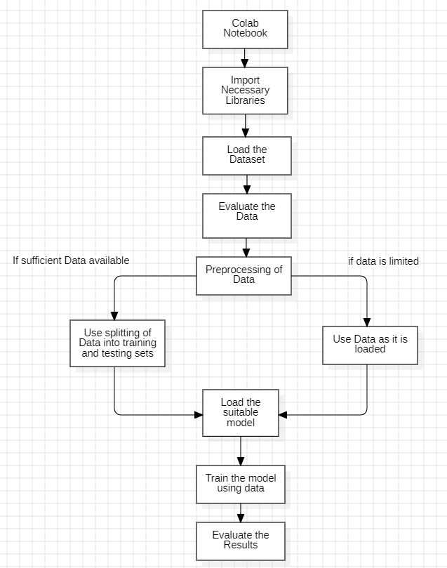

*Figure 1 Data Flow Diagram*

Page12

# Code / Program with Supported Screenshots

### Quiz Game Development using Python

print("--------------WELCOME IN MY QUIZ GAME ")

ans=input("Do you want to start the game?").upper() if ans=="YES":

score=0 print("let's begin")

q1=input("what is 3+9?").lower() if q1=="12" or q1=="twelve":

print("correct") score+=1

else:

print("not correct") score=score-0.25

q2=input("what is color of sky?").lower() if q2=="blue":

print("correct") score+=1

else:

print("not correct") score-=0.25

q3=int(input("Number of planets in Solar System?")) if q2=="8":

print("correct") score+=1

else:

print("not correct") score-=0.25

q4=input("Closest planet to earth is?")).lower() if q2=="Mercury":

print("correct") score+=1

else:

print("not correct") score-=0.25

else:

print("okay") print("score is : ",score)

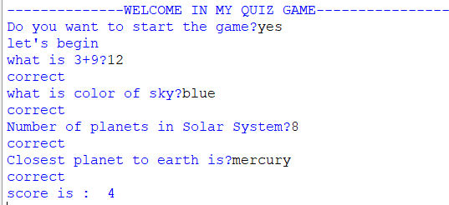

*Figure 2 Output*

Page13

### Area Price Prediction using Python and Google Colab

from google.colab import drive drive.mount('/content/drive')

import pandas as pd

df=pd.read_csv("/content/drive/MyDrive/project/areaprice071.cs")

df.head()

x = df[['area']] x

y = df.price y

import matplotlib.pyplot as plt plt.title("Area vs Price") plt.xlabel("Area") plt.ylabel("Price")

plt.scatter(x,y, color = "red", s = 100, ec = ["blue","yellow "]) plt.show()

pip install scikit-learn

from sklearn.linear_model import LinearRegression model = LinearRegression()

model.fit(x,y) model.predict([[5000]]) model.coef_ model.intercept_

model.coef_ * 5000 + model.intercept_ pred = model.predict(x)

plt.title("Area vs Price") plt.xlabel("Area") plt.ylabel("Price")

plt.scatter(x,y, color = "red", s = 100, ec = ["blue","yellow"]) plt.plot(x, pred, color = "green")

plt.show()

import warnings warnings.filterwarnings("ignore")

myarea = int(input("enter the value of area:")) myprice = model.predict([[myarea]]) print("price is:",myprice[0])

Page14

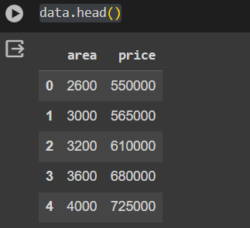 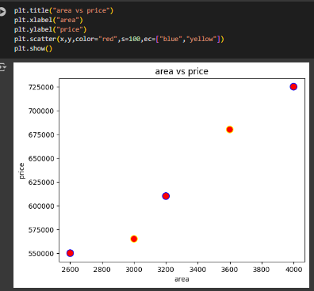 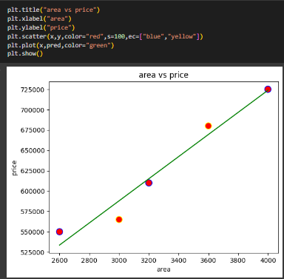

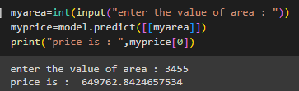

*Figure 3 Area Price Prediction*

### Insurance Purchase Prediction using Python and Google Colab

from google.colab import drive drive.mount('/content/drive')

import pandas as pd

data = pd.read_csv("/content/drive/MyDrive/project /insurance.csv')

data.head()

data.isnull().sum()

#splitting data into dependent and independent variable x = data[['age']]

y = data.bought_insurance import matplotlib.pyplot as plt

plt.title("Age VS Insurance bought") plt.scatter(x, y, color = 'red') plt.xlabel("Age") plt.ylabel("Insurance bought") plt.show()

from sklearn.linear_model import LogisticRegression import warnings

warnings.filterwarnings('ignore') model = LogisticRegression() model.fit(x,y)

Page15

a = int(input("Enter the value of age:")) if model.predict([[a]])[0]==0:

print("Insurance will not be getting bought") else:

print("Insurance will be bought")

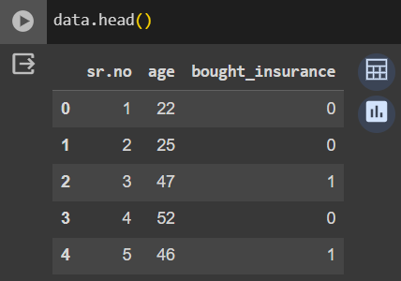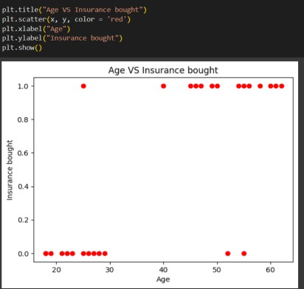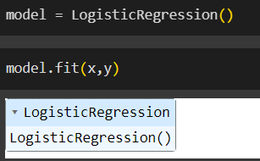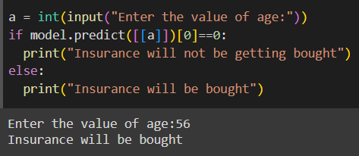

*Figure 4 Insurance Bought Prediction*

### Gender Prediction using Python and Google Colab

from google.colab import drive drive.mount('/content/drive')

import pandas as pd

data = pd.read_csv("/content/drive/MyDrive/project /Bmi_male_female.csv'’) data.head()

x = data[["Height", "Weight"]] y = data.Gender

#Converting into numerical using one-hot encoding Y = pd.get_dummies(y)

Y

from sklearn.tree import DecisionTreeClassifier import warnings warnings.filterwarnings('ignore')

model = DecisionTreeClassifier()

Page16

model.fit(x,Y)

prediction = model.predict([[190,60]]) if prediction[0][0]==0:

print("Female")

else:

print("Male")

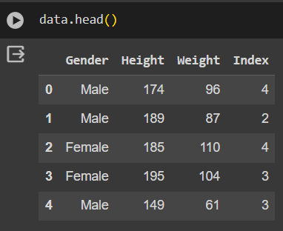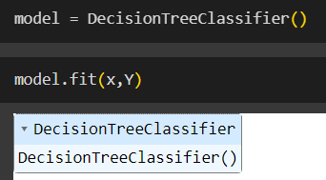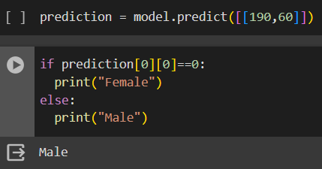

*Figure 5 Gender Prediction*

### Iris Flower Data Analysis with K-Nearest Neighbors

import pandas as pd

from sklearn.datasets import load_iris i = load_iris()

dir(i) i.data.shape i.data[0] i.data_module i.feature_names i.filename

i.data

data = pd.DataFrame(i.data, columns = i.feature_names) data["Species"] = i.target

Page17

data

s = data.groupby("Species") setosa = s.get_group(0) versi = s.get_group(1) virginica = s.get_group(2)

setosa.head() versi.head() virginica.head()

#splitting data

x = data.drop("Species",axis = 1) x

y = data.Species y

import matplotlib.pyplot as plt plt.xlabel("sepal length") plt.ylabel("sepal width")

plt.scatter(setosa["sepal length (cm)"], setosa["sepal width (cm)"], color = "red", label = "setosa") plt.scatter(versi["sepal length (cm)"], versi["sepal width (cm)"], color = "green", label = "versi") plt.scatter(virginica["sepal length (cm)"], virginica["sepal width (cm)"], color = "blue", label = "virginica") plt.legend()

plt.xlabel("petal length") plt.ylabel("petal width")

plt.scatter(setosa["petal length (cm)"], setosa["petal width (cm)"], color = "red", label = "setosa") plt.scatter(versi["petal length (cm)"], versi["petal width (cm)"], color = "green", label = "versi") plt.scatter(virginica["petal length (cm)"], virginica["petal width (cm)"], color = "blue", label = "virginica") plt.legend()

x y

from sklearn.model_selection import train_test_split train_x,test_x,train_y,test_y = train_test_split(x,y,test_size = 0.2) len(train_x)

len(test_x)

from sklearn.neighbors import KNeighborsClassifier model = KNeighborsClassifier(n_neighbors = 2) model.fit(train_x,train_y)

Page18

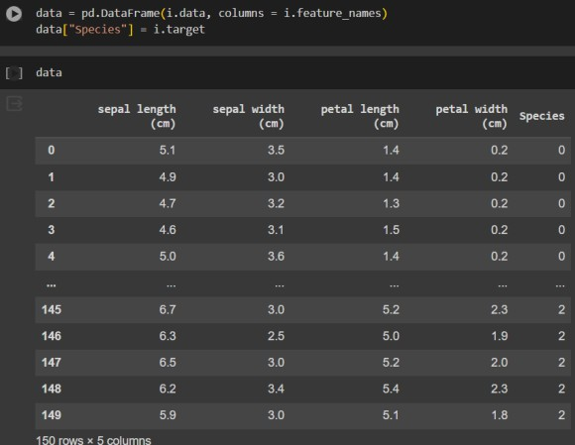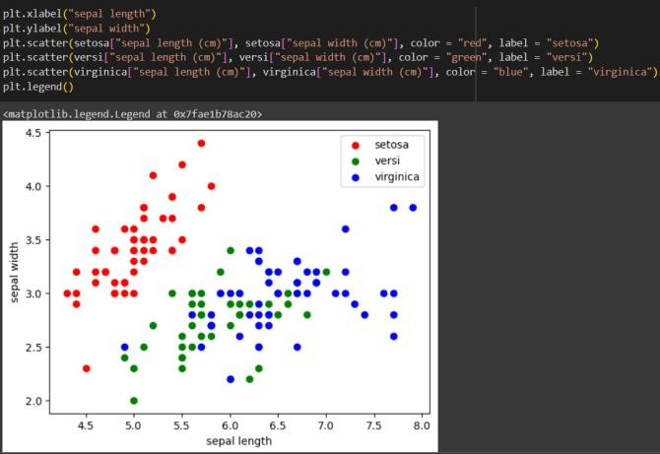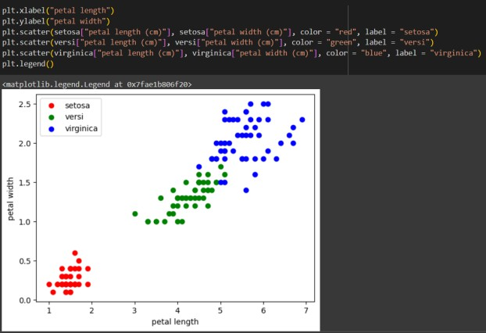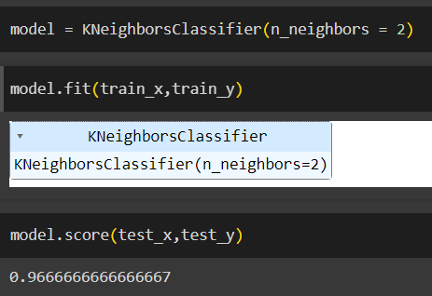model.score(test_x,test_y) model.predict(test_x)==test_y

*Figure 6 KNN Model*

### Titanic Survival Prediction using Python and Google Colab

from google.colab import drive drive.mount('/content/drive')

import pandas as pd import warnings

warnings.filterwarnings('ignore')

data = pd.read_csv('/content/drive/MyDrive/Data Science/Titanic-Dataset.csv') data.head()

data.isnull().sum()

x = data[["Pclass","Sex","Age"]] y = data.Survived

x.isnull().sum()

x.Age.fillna(x.Age.mean(),inplace = True) x

#Converting string to numerical

from sklearn.preprocessing import LabelEncoder le = LabelEncoder()

gen = le.fit_transform(x.Sex)

x["Gender"] = gen

x.drop("Sex",axis = 1, inplace = True) x.isnull().sum()

y

from sklearn.model_selection import train_test_split train_x,test_x,train_y,test_y = train_test_split(x, y,test_size = 0.2) len(train_x)

len(test_x)

from sklearn.linear_model import LogisticRegression model = LogisticRegression() model.fit(train_x,train_y)

model.score(test_x,test_y)

if model.predict([[3,70,1]])==1:

print("Survived") else:

print("Not Survived")

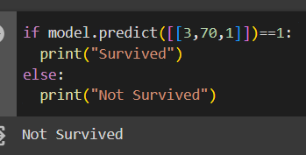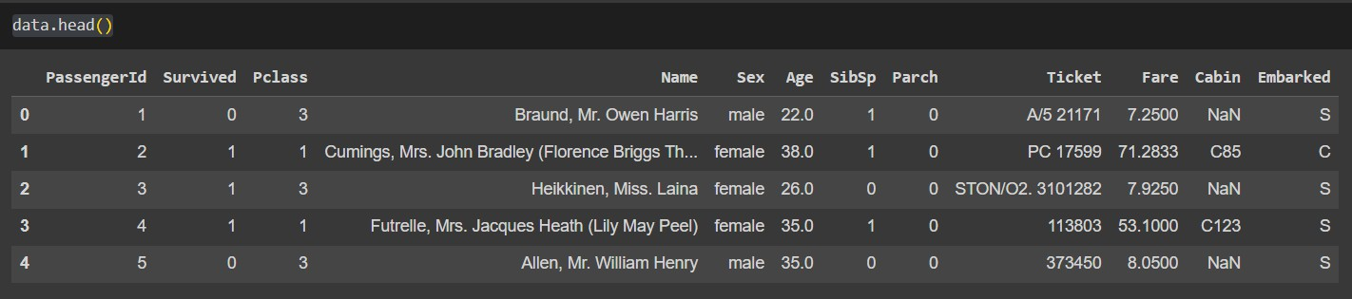

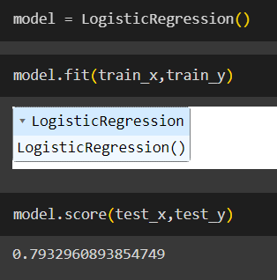

Page19

*Figure 7 titanic survival*

5.7 image classification using Python and Google Colab

d=load_digits()

dir(d)

print(d.DESCR)

d.data.shape

d.data[0]

d.feature_names

d.frame

d.images.shape

d.images

d.data.shape

d.images.shape

d.data[0]

d.images[0]

import matplotlib.pyplot as plt

for i in range(23,28):

plt.matshow(d.images[i])

d.target[23:28]

d.target_names

x=d.data

y=d.target

from sklearn.model_selection import train_test_split

train_x,test_x,train_y,test_y=train_test_split(x,y,test_size=0.2)

len(train_x)

len(test_x)

from sklearn.linear_model import LogisticRegression

import warnings

warnings.filterwarnings("ignore")

model=LogisticRegression()

model.fit(train_x,train_y)

model.predict(test_x[190:191])

test_y[190]

plt.matshow(test_x[190:191].reshape(8,8))

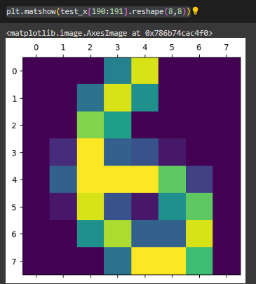 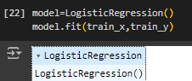

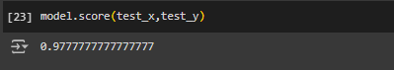

*Figure 8 image classification*

Page20

1. **Input / Output with Datasets & Supported Screenshots**

Page21

### Area Price Prediction using Python and Google Colab

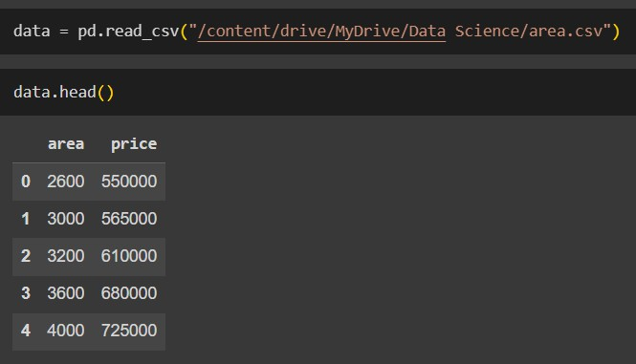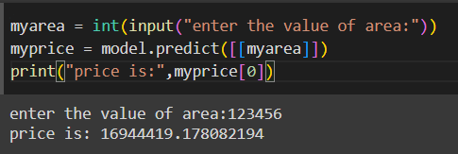

*Figure 8 Input/Output*

### Insurance Purchase Prediction using Python and Google Colab

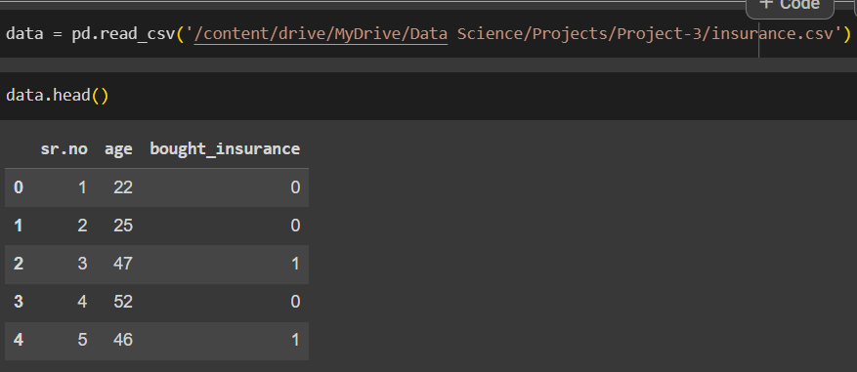 

*Figure 9 Input/Output*

### Gender Prediction using Python and Google Colab

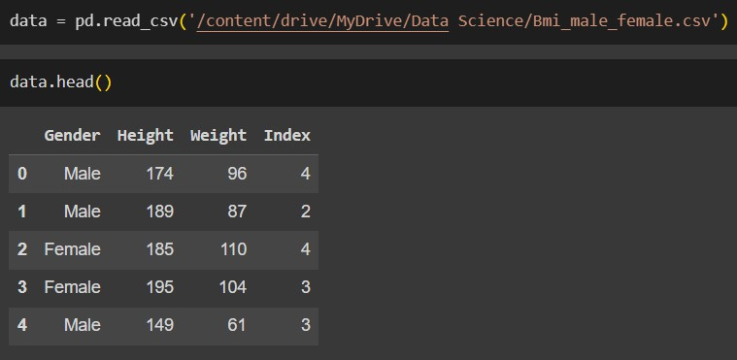

*Figure 10 Input/Output*

Page22

### Iris Flower Data Analysis with K-Nearest Neighbors

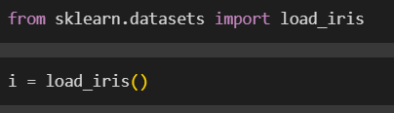 

*Figure 11 Input/Output*

### Titanic Survival Prediction using Python and Google Colab

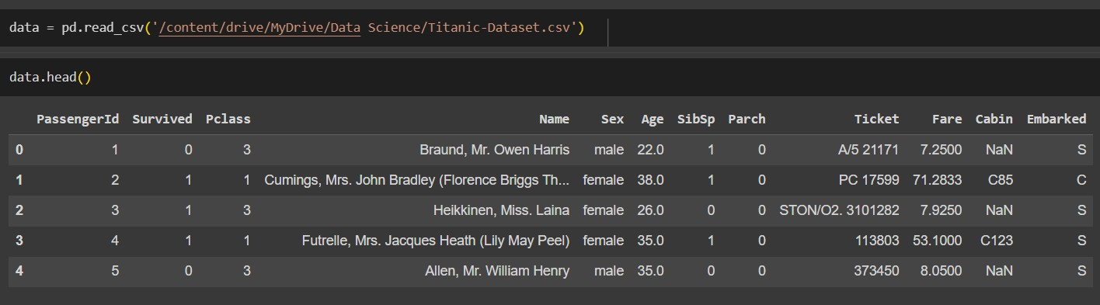



*Figure 12 Input/Output*

* 1. image classification using Python and Google Colab

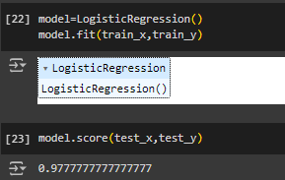 

*Figure 13 Input/Output*

Page23

# Images / Video Links

* [https://eisystemsservices.edmingle.com/myaccount/#/course/65353/lesson/955071?lesson=955071&les](https://eisystemsservices.edmingle.com/myaccount/%23/course/65353/lesson/955071?lesson=955071&lesson_type=material&section=184474&subject=186065) [son_type=material&section=184474&subject=186065](https://eisystemsservices.edmingle.com/myaccount/%23/course/65353/lesson/955071?lesson=955071&lesson_type=material&section=184474&subject=186065)
* <https://github.com/Hari-om07/EIsystems/tree/main/Projects>
* <https://www.youtube.com/watch?v=gmvvaobm7eQ&list=PLeo1K3hjS3uvCeTYTeyfe0-rN5r8zn9rw>
* <https://www.youtube.com/watch?v=C6YtPJxNULA>

Page24

# References

* [**https://www.nrigroupindia.com/e-**](https://www.nrigroupindia.com/e-book/Introduction%20to%20Machine%20Learning%20with%20Python%20(%20PDFDrive.com%20)-min.pdf)[**book/Introduction%20to%20Machine%20Learning%20with%20Python%20(%20PDFDrive.com%20)-**](https://www.nrigroupindia.com/e-book/Introduction%20to%20Machine%20Learning%20with%20Python%20(%20PDFDrive.com%20)-min.pdf)[**min.pdf**](https://www.nrigroupindia.com/e-book/Introduction%20to%20Machine%20Learning%20with%20Python%20(%20PDFDrive.com%20)-min.pdf)
* [**https://www.cin.ufpe.br/~cavmj/Machine%20-%20Learning%20-%20Tom%20Mitchell.pdf**](https://www.cin.ufpe.br/~cavmj/Machine%20-%20Learning%20-%20Tom%20Mitchell.pdf)
* [**https://www.cs.huji.ac.il/~shais/UnderstandingMachineLearning/understanding-machine-learning-**](https://www.cs.huji.ac.il/~shais/UnderstandingMachineLearning/understanding-machine-learning-theory-algorithms.pdf)[**theory-algorithms.pdf**](https://www.cs.huji.ac.il/~shais/UnderstandingMachineLearning/understanding-machine-learning-theory-algorithms.pdf)
* [**https://www.youtube.com/watch?v=yN7ypxC7838**](https://www.youtube.com/watch?v=yN7ypxC7838)

Page25

1. **Student *Self Evaluation of the Short-Term Internship***

**Please rate your performance in the following areas:**

|  |  |  |  |  |  |
| --- | --- | --- | --- | --- | --- |
| **1) Oral communication** | **1** | **2** | **3** | **4** | **5** |
| **2) Written communication** | **1** | **2** | **3** | **4** | **5** |
| **3) Initiative** | **1** | **2** | **3** | **4** | **5** |
| **4) Interaction with staff** | **1** | **2** | **3** | **4** | **5** |
| **5) Attitude** | **1** | **2** | **3** | **4** | **5** |
| **6) Dependability** | **1** | **2** | **3** | **4** | **5** |
| **7) Ability to learn** | **1** | **2** | **3** | **4** | **5** |
| **8) Planning and organization** | **1** | **2** | **3** | **4** | **5** |
| **9) Professionalism** | **1** | **2** | **3** | **4** | **5** |
| **10) Creativity** | **1** | **2** | **3** | **4** | **5** |
| **11) Quality of work** | **1** | **2** | **3** | **4** | **5** |
| **12) Productivity** | **1** | **2** | **3** | **4** | **5** |
| **13) Progress of learning** | **1** | **2** | **3** | **4** | **5** |
| **14) Adaptability to organization’s culture/policies** | **1** | **2** | **3** | **4** | **5** |
| **15) OVERALL PERFORMANCE** | **1** | **2** | **3** | **4** | **5** |



**Signature of the Student**

Page26

# Annexure 1 Daily Activity Report

Week No: 1 (1/2/3/4/5/6/7/8/9/10/11/12/13/14/15/16)

|  |  |  |  |
| --- | --- | --- | --- |
| Day & Date | Brief Description of Daily Activity | Learning Outcome | Person In-Charge |
| Day 1 | Foundation of Python | Basic Information About Data Science | Mallika Srivastava |
| Day 2 | Variable, Constants,  Naming Convention | Knowledge About variable,  naming and constant, | Mallika Srivastava |
| Day 3 | Variables, Constants, Naming Convention | Knowledge About variable,  naming and constant, | Mallika Srivastava |
| Day 4 | Print Function and Comments | Functions like Print and Knowledge About Comments | Mallika Srivastava |
| Day 5 | Print Function and Comments | Functions like Print and Knowledge About Comments | Mallika Srivastava |

*Table 1*

Week No: 2 (1/2/3/4/5/6/7/8/9/10/11/12/13/14/15/16)

|  |  |  |  |
| --- | --- | --- | --- |
| Day & Date | Brief Description of Daily Activity | Learning Outcome | Person In-Charge |
| Day 1 | Different types of Datatypes (String, list) | Information About Datatypes in python | Mallika Srivastava |
| Day 2 | Different types of Datatypes (Tuple, Dictionary) | Information About Datatypes in python | Mallika Srivastava |
| Day 3 | Different types of Datatypes (set, boolean) | Information About Datatypes in python | Mallika Srivastava |
| Day 4 | User Input and Typecasting | Basic Information About inputs given by user | Mallika Srivastava |
| Day 5 | Control Statements | Knowledge About Control Statements like if, else, elif | Mallika Srivastava |

*Table 2*

Page27

|  |  |  |  |
| --- | --- | --- | --- |
| Day & Date | Brief Description of Daily Activity | Learning Outcome | Person In-Charge |
| Day 1 | Project-1 Quiz Games | Develop project on Quiz games using python interpreter | Mallika Srivastava |
| Day 2 | Loop in Python | Information About While, for loops | Mallika Srivastava |
| Day 3 | File handling | Information About Filehandling in python | Mallika Srivastava |
| Day 4 | Function | Information About Functions in python | Mallika Srivastava |
| Day 5 | Packages and Modules | Knowledge About Packages and Modules | Mallika Srivastava |

*Table 3*

Week No: 4 (1/2/3/4/5/6/7/8/9/10/11/12/13/14/15/16)

|  |  |  |  |
| --- | --- | --- | --- |
| Day & Date | Brief Description of Daily Activity | Learning Outcome | Person In-Charge |
| Day 1 | Exception Handling | Knowledge about Exception Handling python | Mallika Srivastava |
| Day 2 | OOPS Concept (part-1, part-2) | Information About Object Oriented Programming | Mallika Srivastava |
| Day 3 | OOPS Concept (part-3, part-4) | Information About Object Oriented Programming | Mallika Srivastava |
| Day 4 | OOPS Concept (part-5) | Information About Object Oriented Programming | Mallika Srivastava |
| Day 5 | Numpy (Part-1) | Information About Numpy library in python | Mallika Srivastava |

*Table 4*

Page28

|  |  |  |  |
| --- | --- | --- | --- |
| Day & Date | Brief Description of Daily Activity | Learning Outcome | Person In-Charge |
| Day 1 | Numpy (Part-2) | Information About Numpy library in python | Mallika Srivastava |
| Day 2 | Numpy (Part-3) | Information About Numpy library in python | Mallika Srivastava |
| Day 3 | Numpy (Part-4) | Information About Numpy library in python | Mallika Srivastava |
| Day 4 | Pandas (Part-1) | Information About Pandas library in python | Mallika Srivastava |
| Day 5 | Pandas (Part-2) | Information About Pandas library in python | Mallika Srivastava |

*Table 5*

Week No: 6 (1/2/3/4/5/6/7/8/9/10/11/12/13/14/15/16)

|  |  |  |  |
| --- | --- | --- | --- |
| Day & Date | Brief Description of Daily Activity | Learning Outcome | Person In-Charge |
| Day 1 | Pandas (Part-3) | Information About Pandas library in python | Mallika Srivastava |
| Day 2 | Pandas (Part-4) | Information About Pandas library in python | Mallika Srivastava |
| Day 3 | Matplotlib | Information About Matplotlib library in python | Mallika Srivastava |
| Day 4 | Model Understanding  (LinearRegression, LogisticRegression) | Understanding different models in python | Mallika Srivastava |
| Day 5 | Model Understanding (SVM, DecisionTree) | Understanding different models in python | Mallika Srivastava |

*Table 6*

Page29

|  |  |  |  |
| --- | --- | --- | --- |
| Day & Date | Brief Description of Daily Activity | Learning Outcome | Person In-Charge |
| Day 1 | Projects (1) | Projects on area price prediction | Mallika Srivastava |
| Day 2 | Projects (2) | Projects on multiple data of area price prediction | Mallika Srivastava |
| Day 3 | Projects (3) | Projects on insurance bought by different ages | Mallika Srivastava |
| Day 4 | Projects (4) | Projects gender prediction using height and weight | Mallika Srivastava |
| Day 5 | Projects (5) | Projects on iris data exploration using KNN | Mallika Srivastava |

*Table 7*

Week No: 8 (1/2/3/4/5/6/7/8/9/10/11/12/13/14/15/16)

|  |  |  |  |
| --- | --- | --- | --- |
| Day & Date | Brief Description of Daily Activity | Learning Outcome | Person In-Charge |
| Day 1 | Projects (6) | Projects on iris data exploration using SVM | Mallika Srivastava |
| Day 2 | Projects (7) | Projects on Survival rate prediction of Titanic Dataset | Mallika Srivastava |
| Day 3 | Streamlit | Understanding Streamlit in python | Mallika Srivastava |
| Day 4 | Model building | Model building for area price prediction | Mallika Srivastava |
| Day 5 | Model Deployment | Model Deployment Using Streamlit | Mallika Srivastava |

*Table 8*

Page30

# Annexure 2 Weekly Progress Report

Week No: (1/2/3/4/5/6/7/8/9/10/11/12/13/14/15/16)

|  |  |  |  |
| --- | --- | --- | --- |
| Week(s) | Summary of Weekly Activity | | |
| Week 1 | It covered foundational topics in data pythons and programming. It began with an overview of python and progressed to machine learning fundamentals.  Participants learned Python basics, including variables, constants, and naming conventions. The week concluded with an introduction to essential functions like  printing and commenting in Python code. | | |
| Week 2 | It delved into Python's diverse data types, covering strings, lists, tuples, dictionaries, sets, and booleans. Participants learned about user input and typecasting, gaining the ability to interact with their programs dynamically. Additionally, they explored control  statements like if, else, and elif, empowering them to manage program flow effectively. | | |
| Week 3 |  | It focused on practical application and advanced concepts in Python. Participants developed a Quiz game project using Python, demonstrating their understanding of loops, file handling, functions, and utilizing packages and modules for efficient code organization. They gained proficiency in implementing loops such as while and for, managing files, defining functions, and organizing code into reusable packages and  modules, enhancing their programming skills. |  |
| Week 4 | It focused on enhancing Python programming skills with an emphasis on handling errors through Exception Handling. Days 2-4 were dedicated to Object-Oriented Programming (OOP) concepts, covering various aspects such as classes, objects, inheritance, polymorphism, and encapsulation. The week concluded with an introduction to the NumPy library, providing insights into its functionalities for numerical computing and data manipulation. Participants gained a solid foundation in these essential programming concepts, setting the stage for more advanced topics in the following  weeks. | | |
| Week 5 | It was dedicated to exploring the essential functionalities of two fundamental Python libraries: NumPy and Pandas. Participants delved into NumPy across Days 1-3, gaining insights into its capabilities for numerical computing and data manipulation. Days 4-5 shifted focus to Pandas, covering its functionalities for data analysis and manipulation,  thus laying a strong foundation for handling and analyzing data effectively in Python. | | |
| Week 6 | It began with a focus on Pandas, covering advanced functionalities such as data manipulation and analysis across Days 1-2. Participants then explored the Matplotlib library on Day 3, learning how to create various types of plots and visualizations in Python. The latter part of the week shifted to understanding different machine learning models, including Linear Regression and Logistic Regression on Day 4, and Support Vector Machines (SVM) and Decision Trees on Day 5. This week provided participants with a deeper understanding of data manipulation, visualization, and machine learning  concepts in Python. | | |
| Week 7 | It was filled with hands-on projects covering various real-world scenarios. Participants started with predicting area prices, exploring multiple datasets related to area price prediction, and analyzing insurance purchases by different age groups. Day 4 focused on gender prediction using height and weight data, while Day 5 delved into iris data exploration using the KNN algorithm. This week provided practical experience in data analysis, prediction, and classification tasks, enhancing participants' skills in Python  programming and machine learning. | | |

Page31

|  |  |
| --- | --- |
| Week 8 | It began with a project exploring iris data exploration using the Support Vector Machine (SVM) algorithm, providing hands-on experience with classification tasks. Day 2 focused on predicting survival rates using the Titanic dataset, allowing participants to apply machine learning techniques to real-world scenarios. Day 3 introduced Streamlit, enabling participants to create interactive web applications for data visualization and model deployment. On Day 4, participants engaged in model building specifically for area price prediction, further honing their machine learning skills. The week concluded with a focus on deploying models using Streamlit, empowering participants to  showcase their work through user-friendly interfaces. |

*Table 9*